**Online Travel Management System**

**552350 - Gowthami**

# Git Lab Project Name 552350_CDES2_TripService_08292019

**Back End microservices** :

**TripService -** Login functionality using JWT and crud operations for user details and Admin.

TripService module lists the trip details of Employee, Admin and Customer.

* Admin should be able to view trip detail of all the employees.
* Employee will view only his/her trip details.

**TripServiceUI –** Developed using Angular

**Angular Port** – 4200

**MSA service** - 8088

MSA Architecture 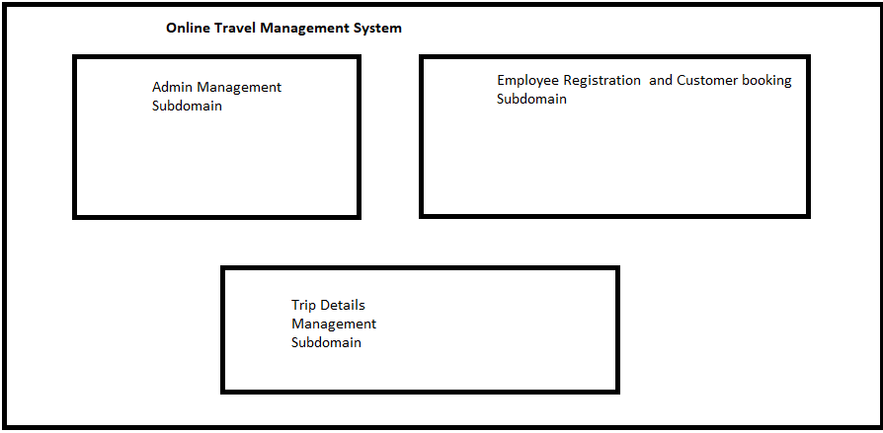

**Admin User - Login**

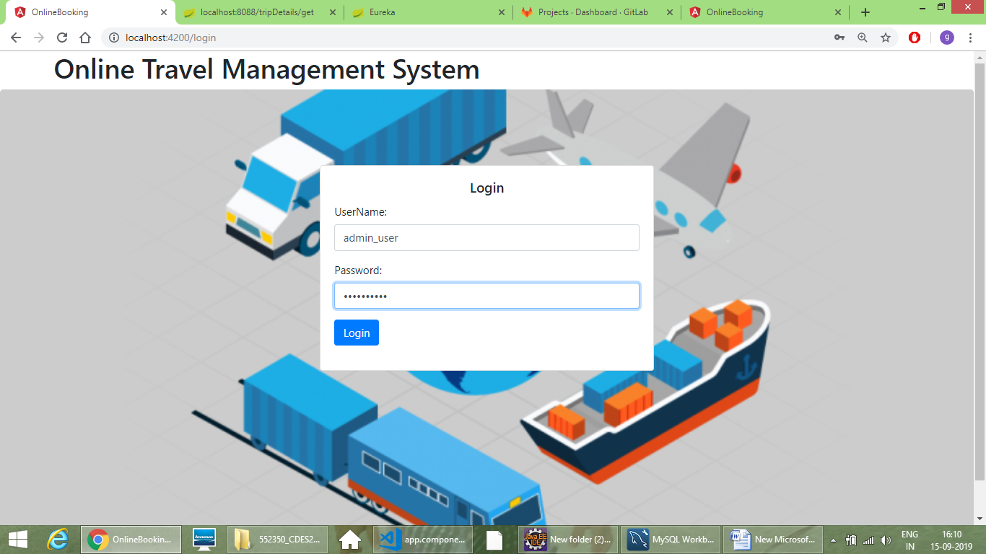

Admin can view the customer and employee details and travel status.

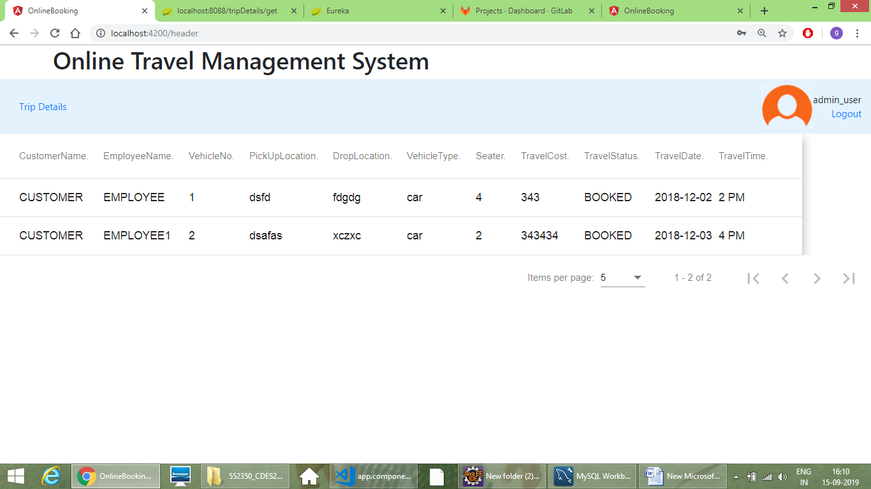

**Customer can view his trip when he/she login the application**

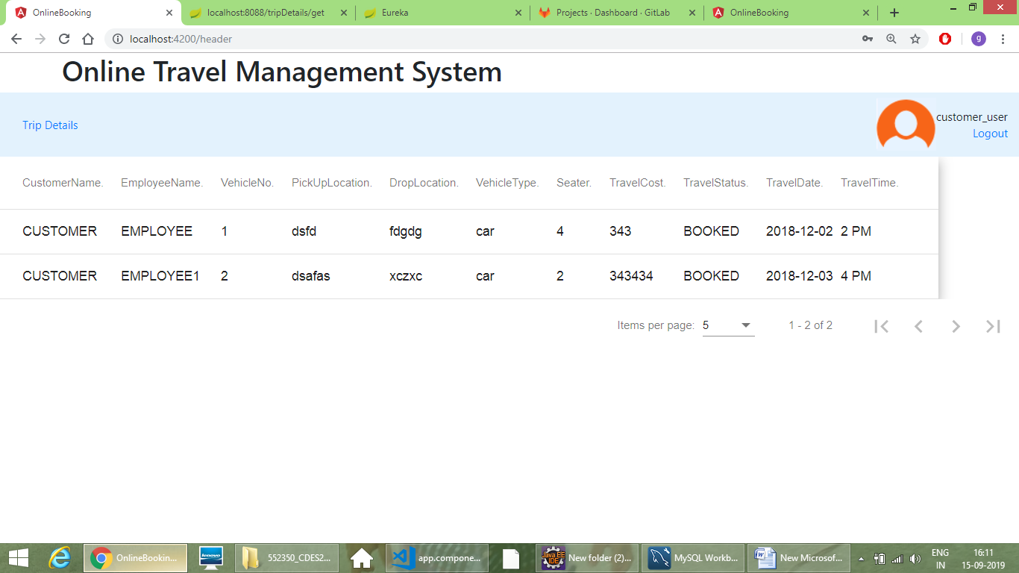

**Employee**

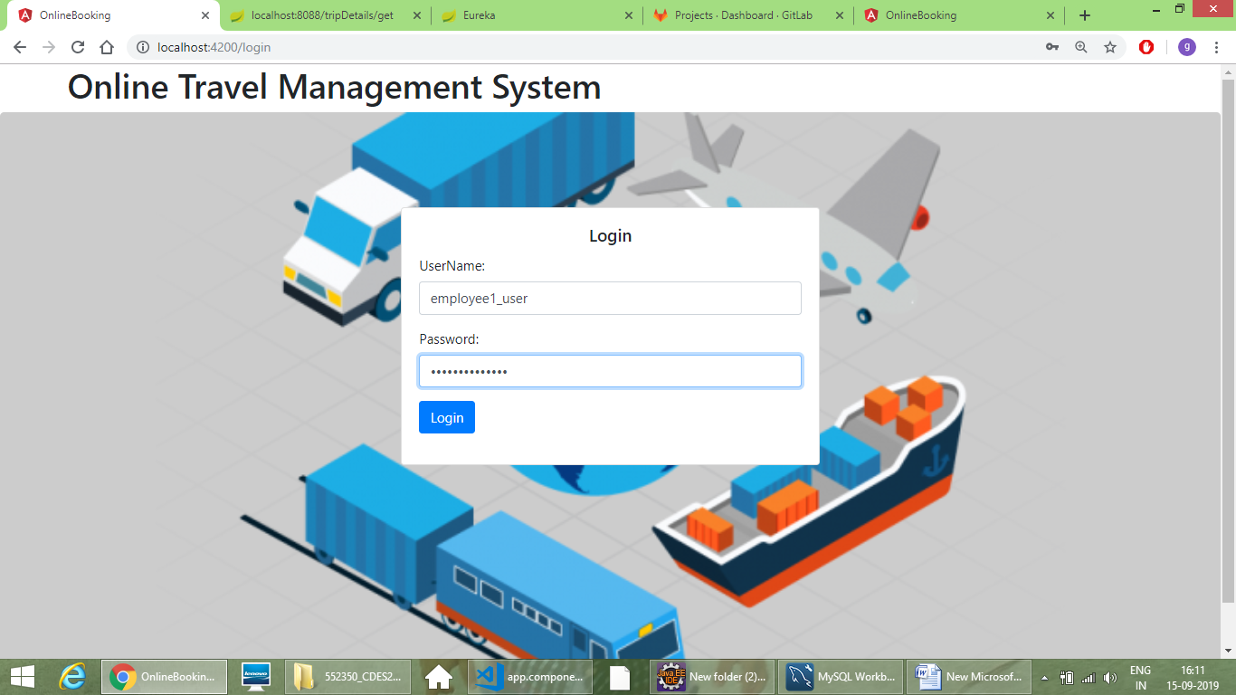

Employee can view his customer booking and trip details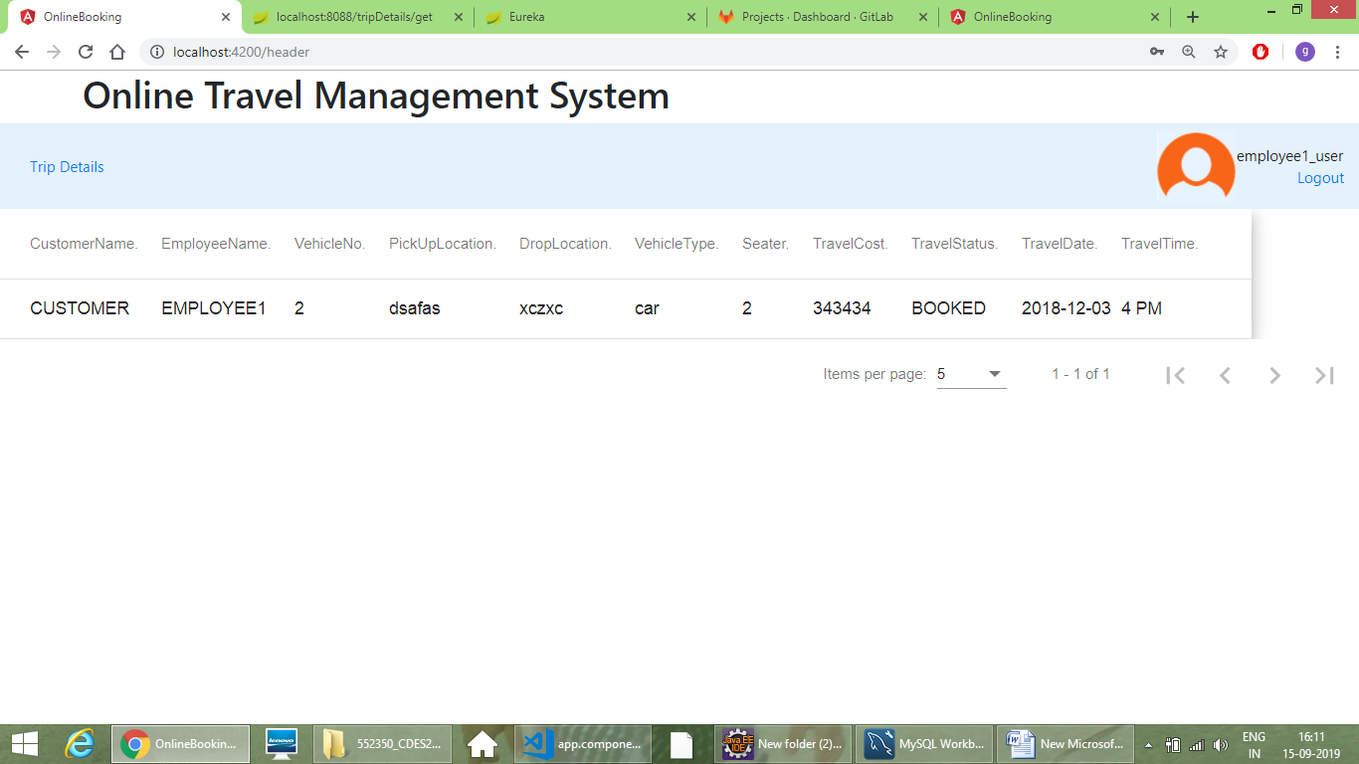

Eureka Server – Trip Service is registered with Eureka